
Mill Creek Cost-Share Program Description and Eligibility
Administered by H2Ozarks

Program Overview

Program Contacts:
Ayla Grace, Project Coordinator, ayla@h2ozarks.org, 479-866-7220
Erin Scott, Senior Policy and Program Director, erin@h2ozarks.org, 479-841-0235

Purpose of this Program:
The Mill Creek Cost-Share Program is designed to support landowners in implementing conservation practices (CPs) that enhance natural resource management, improve water quality, and promote sustainable agricultural practices within the Mill Creek subwatershed and a portion of the Crooked Creek subwatershed (see pages 3-4 for details about eligible locations).

This initiative builds upon ongoing outreach and education efforts in the program area, which has been identified as a priority area for nonpoint source pollution control. Despite its significance, this portion of the Buffalo River Watershed has received limited outreach and implementation efforts. This program seeks to bridge this gap by providing financial and technical assistance to empower landowners to adopt CPs that yield both economic and environmental benefits.

Key goals of the program include:
- Highlighting the dual benefits of CPs by improving water quality while delivering long-term economic advantages to landowners.
- Reducing nonpoint source pollution, such as sediment, nutrients, and pathogens, that impact local waterways.
- Encouraging practices that restore and protect riparian zones, pasture land, and forest land.

These goals will be achieved through the following specific objectives of this program:
- Work with landowners to develop up to 10 land management plans.
- Work with landowners to provide financial assistance to install up to 10 conservation practices.

Program Funding

Funding Source:
This program is made possible through funding from the Arkansas Natural Resources Division 319 Non-Point Source Pollution Program and the Environmental Protection Agency and through partnership with the Boone County Conservation District, the U.S. Department of Agriculture Natural Resources Conservation Service, Quail Forever, the Arkansas Forestry Commission, the University of Arkansas Division of Agriculture Cooperative Extension Service, and others.

Funding Structure:
The Mill Creek Cost-Share Program offers financial assistance to landowners to offset the cost of implementing conservation practices. The cost-share structure is designed to maximize participation while addressing environmental and economic priorities.

Conservation Practice Installation
Financial support is available for installing a variety of conservation practices. The cost-share rates and caps vary by practice (see Appendix 1 for a full list of eligible practices and their associated cost-share rates and caps):
- 100% Cost Share
Certain high-priority practices are covered at 100%, up to a maximum of $7,500 per project. Landowners are responsible for any costs that exceed the program’s maximum limits.
- 80% Cost Share
Other eligible practices are covered at 80%, up to a maximum of $7,500 per project. Landowners are responsible for 20% of the project costs plus any costs that exceed the program’s maximum limits.
All conservation practices must be guided by an existing land management plan and site assessment. The reimbursement amount for projects costs shall be the lesser between the estimated project cost based on NRCS Payment Schedules and the actual project cost. All project expenditures must be identified in itemized receipts to be eligible for reimbursement.

This program also encourages landowners to have a Land Management Plan developed. Not only is a Plan a required component for eligibility in the cost-share for conservation practice installation described above, but also a good first step toward identifying management alternatives to help meet landowner goals.

Land Management Plan Development
The program encourages the development of the following land management plans:
- Nutrient Management Plans
- Forest Management Plans
- Grazing Management Plans
- Soil Health Management Plans
- Prescribed Burning Plans
Plans must align with program objectives and be developed by approved partners, which include: Boone Country Conservation District, Newton County Conservation District, USDA NRCS, Quail Forever, Arkansas Forestry Commission, Arkansas Department of Agriculture Natural Resources Division, University of Arkansas Cooperative Extension Service.

Key Notes on Cost-Share Funding:
- Landowners are responsible for any costs that exceed the program’s maximum limits, as described above.
- All cost-share reimbursements are contingent upon pre-approval of practices, completion of the project according to program specifications, and submission of required documentation.
- Only practices listed in Appendix 1 are eligible for reimbursement under this program.

The tiered cost-share structure ensures that critical conservation practices and planning efforts are accessible while promoting sustainable land management and water quality improvements.

Eligibility Requirements

To participate in the Mill Creek Cost-Share Program, applicants must meet the eligibility criteria detailed below.

Landowner/Participant Requirements:
- Applicants must own or have management authority for the land on which the conservation practice is proposed to be installed. Landowners must provide proof of ownership or management authority, such as a deed, lease agreement, or similar documentation.
- The land must be located within the program’s designated area – inside the Mill Creek (a.k.a., Flatrock Creek) subwatershed of the Buffalo River Watershed OR the Dogpatch Springs Recharge Area covering a portion of the Crooked Creek subwatershed to the north. See Figure 1 for a map of the program area; H2Ozarks staff can help verify eligible locations.
- For conservation practice installations, an appropriate Management Plan must already exist or be developed first.
- Participants must demonstrate a commitment to implementing and maintaining the conservation practices funded by the program for the period of life expectancy of the practice, as outlined in the program agreement.
- The proposed project must be for practice(s) listed in Appendix 1.
- The project must address one or more program goals, such as improving water quality or reducing nonpoint source pollution.
- Applicants must agree to allow program staff or their designees access to the project site for a final inspection after installation is complete. The site will only be accessed with landowner approval and scheduling.
- Participants must provide all required documentation, including a completed application, maps, and any other supporting materials specified by the program.
- Applicants must comply with all local, state, and federal regulations related to the proposed practices.
Application Process
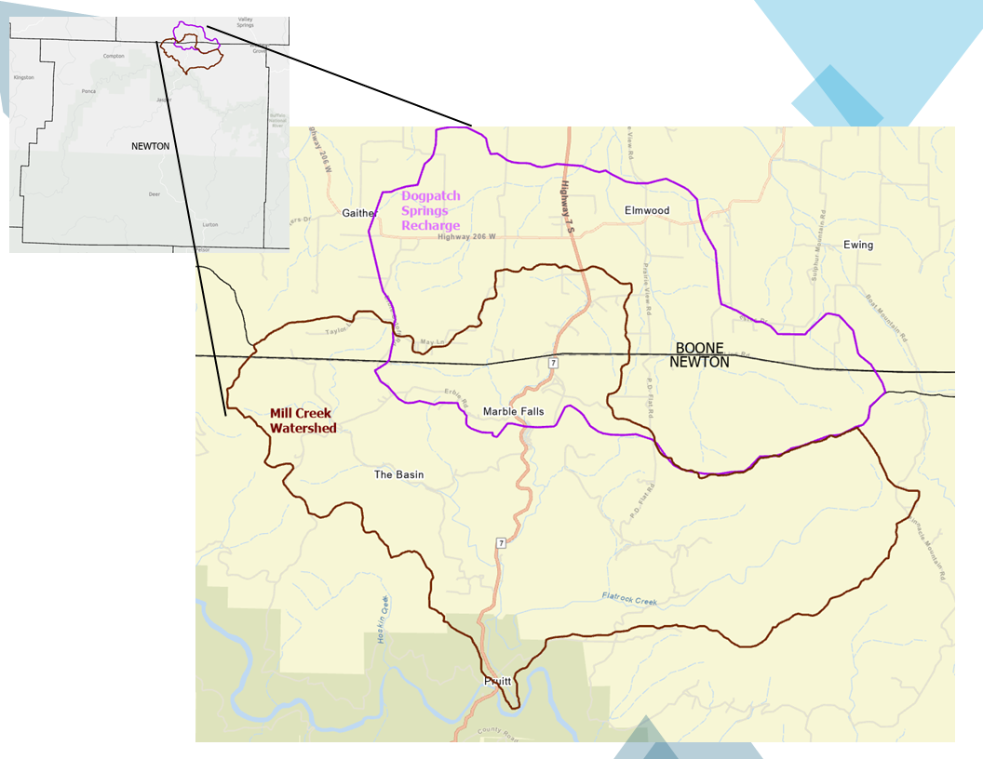
Figure 1. Map of the cost-share program area, covering the Mill Creek subwatershed (maroon outline) and the Dogpatch Springs Recharge Area (purple outline).

Applying for the Mill Creek Cost-Share Program is a straightforward process designed to ensure transparency and efficiency. Follow these steps below to submit your application.

Step 1 - Review Program Information:
Before applying, review this document which describes the program guidelines, eligibility requirements, and cost-share details.

Step 2 – Complete and Compile the Following Items:
- Proof of land ownership or management authority – may be a deed, lease agreement, or similar documentation.
- Application form*.
  - The application form must be completed and signed by the landowner.
  - On this form you will provide applicant information, property and site location information, and a description of your proposed project.
  - This form also indicates other supporting documentation that is needed to process the application.
- Cost-Share Fund Allocation Request form*.
  - This form must be completed and signed by the landowner.
  - On this form you will provide an estimate of the project costs based on the NRCS payment schedule or other approved cost benchmarks.
  - H2Ozarks will assist with this as needed.
- Cost-Share Agreement form*.
  - This must be completed and signed by the landowner.
  - H2Ozarks will assist with this as needed.
  - This form must also be reviewed by NRCS and submitted to H2Ozarks.
*You can find the required forms described below online at: https://www.h2ozarks.org/landowner-assistance-program or you can contact Ayla Grace, ayla@h2ozarks.org or 479-866-7220 to have the forms emailed or paper mailed to your address.

Step 3: Submit Your Application
Submit your completed application and supporting documents to the project coordinator, Ayla Grace:
- By Email: ayla@h2ozarks.org
- By Mail: 1200 W. Walnut St., Rogers, AR 72758

Step 4: Application Review Process
Applications will be reviewed on a monthly rolling basis. All applications submitted from the first day through the last day of the month will be evaluated together.

In the event that proposed funding requests exceed the funding available for a given review period, applications will be ranked from highest to lowest priority based on the following criteria:
- The potential water quality benefits of the proposed project.
- Alignment with program goals and priority areas, such as reducing nonpoint source pollution.
- Feasibility and likelihood of successful implementation of the proposed practices.
- Other factors deemed relevant by program staff to ensure effective use of program funds.

Program staff will notify applicants of approval decisions within 15 business days after the application deadline.

Step 5: Agreement and Implementation
Approved applicants will be required to:
- Sign a program agreement outlining responsibilities, timelines, and funding terms.
- Collaborate with program staff to finalize project details and schedule implementation.
- Allow a site visit upon completion of the project as a means to document the final inspection.

By following these steps, you can participate in a program that helps enhance your land management practices while protecting vital natural resources.

Project Completion and Financial Reimbursement

Once a project application is approved, the following steps outline the process for successful implementation and landowner reimbursement:

1. Project Timeline:
- Approved applicants should complete the project as soon as possible, and within at least 1 year from the date of approval to complete the project.

2. Technical Support:
- H2Ozarks staff and program partners will provide technical support during the project planning and implementation phases to ensure the project meets program specifications.

3. Funding Disbursement:
- Funding is provided as a reimbursement to the landowner upon project completion and successful inspection.
- The reimbursement amount will be the lesser of:
  - The expected costs of implementation as listed in the NRCS payment schedule for the practice.
  - The actual costs expended as reflected by receipts.
- Itemized receipts for all costs are required for reimbursement to be processed.
- Reimbursement is expected to take up to 20 business days.

Appendix 1. Eligible practices, including the NRCS practice number, practice name, the percentage reimbursed by H2Ozarks, and the maximum amount paid. Any costs exceeding the maximum amount paid is the full responsibility of the landowner.

Practice number | Practice name | Percentage paid (up to the max.) | Maximum paid
338 | Prescribed Burning | 100 | $ 7,500.00
342 | Critical Area Planting | 100 | $ 7,500.00
378 | Pond | 100 | $ 7,500.00
381 | Silvopasture | 100 | $ 7,500.00
390 | Riparian herbaceous cover | 100 | $ 7,500.00
391 | Riparian forest buffer | 100 | $ 7,500.00
393 | Filter strip | 100 | $ 7,500.00
394 | Firebreak | 100 | $ 7,500.00
472 | Access control | 100 | $ 7,500.00
490 | Tree/Shrub Site Preparation | 100 | $ 7,500.00
516 | Livestock Pipeline | 100 | $ 7,500.00
528 | Prescribed Grazing | 100 | $ 7,500.00
590 | Nutrient Management | 100 | $ 7,500.00
612 | Tree/Shrub Establishment | 100 | $ 7,500.00
614 | Watering facility | 100 | $ 7,500.00
666 | Forest Stand Improvement | 100 | $ 7,500.00
805 | Amending Soil Properties with Lime | 100 | $ 7,500.00
578 | Stream Crossing | 100 | $ 7,500.00
580 | Streambank and Shoreline Protection | 100 | $ 7,500.00
601 | Vegetative Barrier | 100 | $ 7,500.00
635 | Vegetated Treatment Area | 100 | $ 7,500.00
332 | Contour Buffer Strips | 100 | $ 7,500.00
386 | Field Border | 100 | $ 7,500.00
382 | Fence | 100 | $ 7,500.00
561 | Heavy Use Area Protection | 100 | $ 7,500.00
340 | Cover Crop | 100 | $ 7,500.00
314 | Brush Management | 80 | $ 7,500.00
315 | Herbaceous Weed Control | 80 | $ 7,500.00
484 | Mulching | 80 | $ 7,500.00
512 | Pasture and Hay Planting | 80 | $ 7,500.00
558 | Roof Runoff Structure | 80 | $ 7,500.00
587 | Structure for Water Control | 80 | $ 7,500.00

